**159.339 Assignment 2**

**First National Bank’s internet banking system**

**General Report**

**Pei Wang 15374675**

**Shenchuan Gao 16131180**

**Yunseong Choi 13135649**

1. Requirement Specification 3

1.1 Log-in/Join/Log-out 3

1.2 Accounts (Open/ Close /View) 3

1.3 Transaction 4

1.4 Payment 4

1.5 ATM 5

1.6 Filter 5

2. Design Choices 5

2.1 Login MVC Diagram 5

2.2 Account MVC Diagram 6

2.3 Transaction MVC Diagram 6

2.4 Payment MVC Diagram 7

2.5 ATM MVC Diagram 7

3. Database schema and relations 8

4. Installation instructions 9

4.1 Vagrant up and Vagrant SSH is done 9

4.2 Type the directory where sqldump.sql (cd /vagrant/dev339/sql) and check files 10

4.3 Type MySQL -uroot -p 11

4.4 Type Source sqldump.sql 12

4.5 type select* from table name for checking db is working 13

4.6 Check Working with dev339.local 14

5. Instructions for end-user 15

5.1 Description of Running Environment 15

5.2 How to Use Functions 15

# 1. Requirement Specification

In assignment 2, our task is to create a PHP/MySQL application for First National Bank’s internet banking system, which could offer the following functionality to a customer:

## 1.1 Log-in/Join/Log-out

### Join Page

First name, last name, address, phone number, date of birth, password (hashed), repeat password. Create user information and first account information. Link to log-in page.

### Log-in Page

User name, password, link to Join page, check hashed password in the database (fail - display log-in error; success - go to user homepage), “remember me” (transfer cookie to browser, 7days; If user visit any function, cookie will accept it if the user cookie is valid, transfer it to the target page).

### Change password Page

Old password (check password in the database), new password, repeat new password, hash new password.

### Log-out Page

Cookie should be destroyed. Login status, session. Go to index page.

## 1.2 Accounts (Open/ Close /View)

### User home page

Change password link, log-out link. Appear on every page after log in. Account list (Base account, automatically created; Other account). Account number (00-0000-0000000-00), balance, created date, status. Link to show transaction of the account. Link to create account. Link to edit account.

### Create account Page

Editor page, including account number, description, balance (default 0).

Create account in the database, check duplicated account number.

### Edit account Page

Editor page, including account number, description, balance (default 0).

User can just change description and status. If the account is closed, it cannot be open anymore. The number of opened accounts should be under 5. Base account cannot be closed. If the account has balance, it cannot be closed.

## 1.3 Transaction

### Transaction list Page

Account number(header), balance, description, open date.

Transaction table shows transaction list, including line number in the table, type (Withdraw, Deposit, Transfer - transfer money to another account), description of the transaction (Withdraw machine number……), amount, time, balance after transaction.

Search condition from date to date.

### Transfer Page

User can select source account and destination account, input amount, description, submit and menu (left).

### Transfer result page

Two new transaction records (one is for source, and the other one is for destination) in database with type “F” and “T”, the source account will menus amount, and destination account will plus amount.

## 1.4 Payment

### Payment Page

Payment is from people to people, including input the destination account number, select user account, input amount, and submit.

### Payment result Page

The result page for payment result. Type ‘P’ is recorded (one is for source, the other one is for destination)

## 1.5 ATM

### ATM Simulator

Account(selected), amount(input), select function (Withdraw or Deposit), check balance of the withdraw account (the balance must be greater or equal to withdraw amount), new transaction.

### ATM result page

Result page (fail or success).

## 1.6 Filter

### Filter Page

Filter from the menu include account number, transaction type, from date to date, description, sort by date ASC/DESC order. All the information showed in the table is very similar with the transaction page but without balance.

# 2. Design Choices

## 2.1 Login MVC Diagram

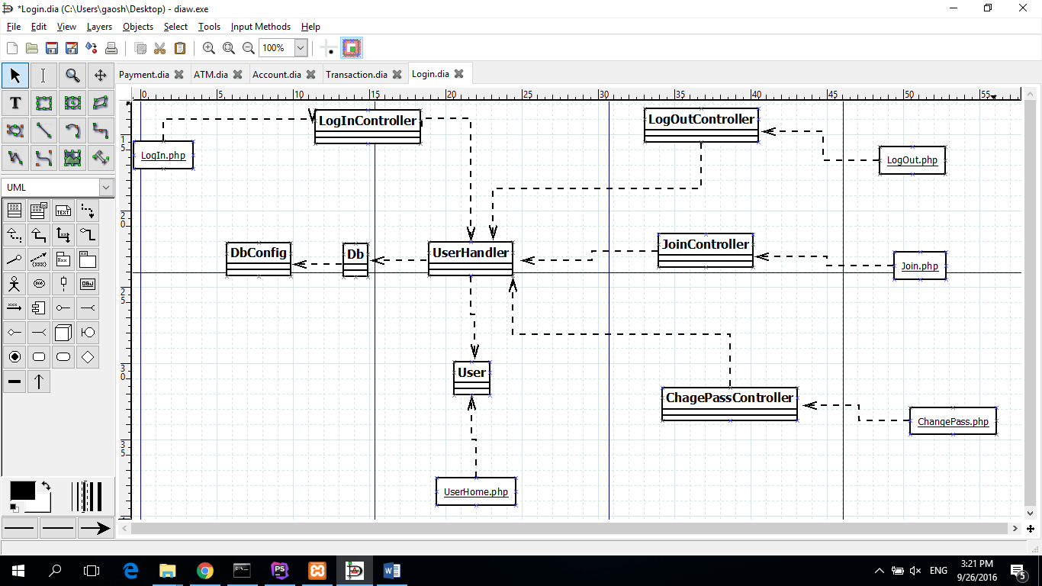

## 2.2 Account MVC Diagram

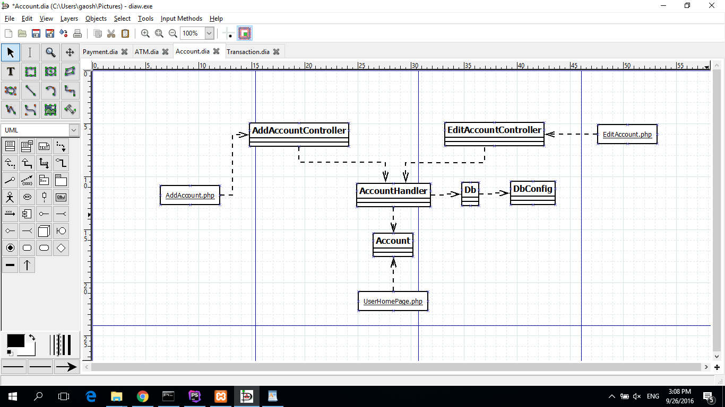

## 2.3 Transaction MVC Diagram

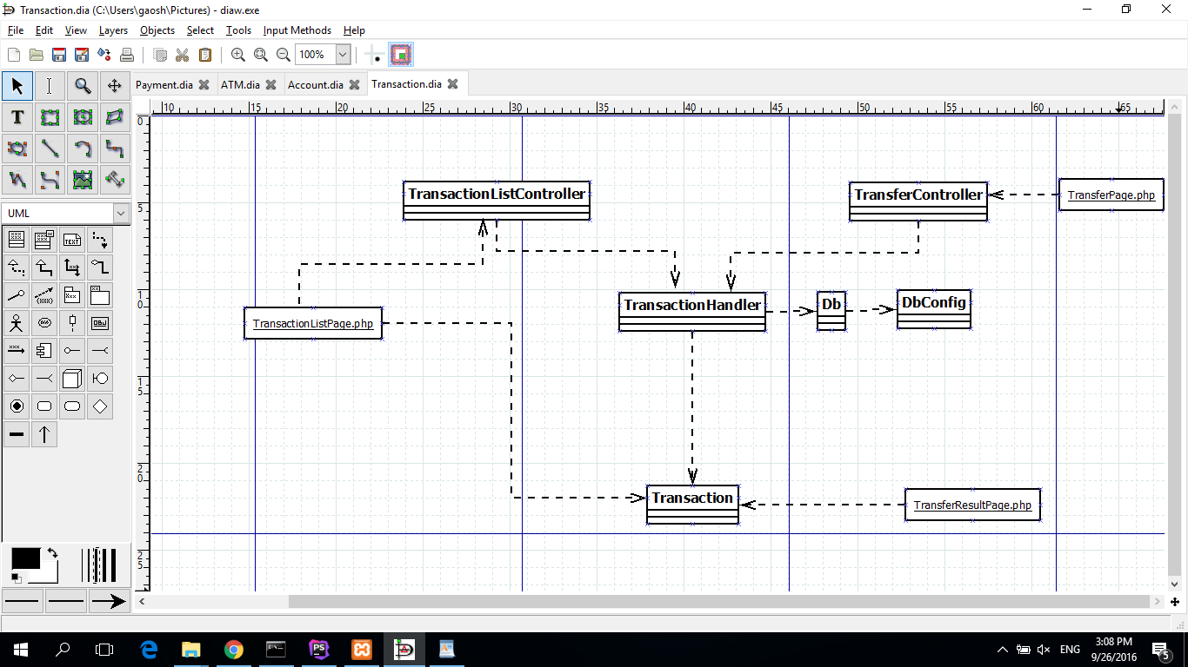

## 2.4 Payment MVC Diagram

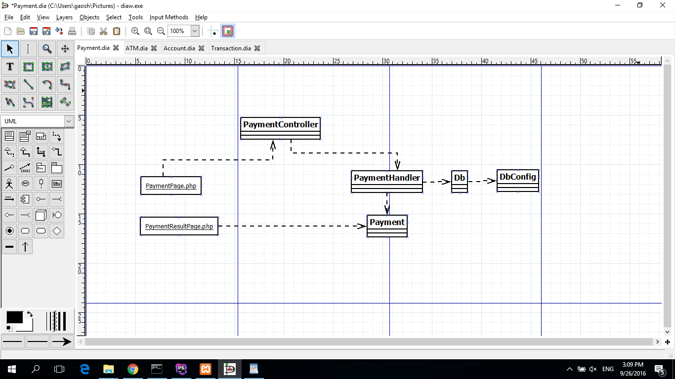

## 2.5 ATM MVC Diagram

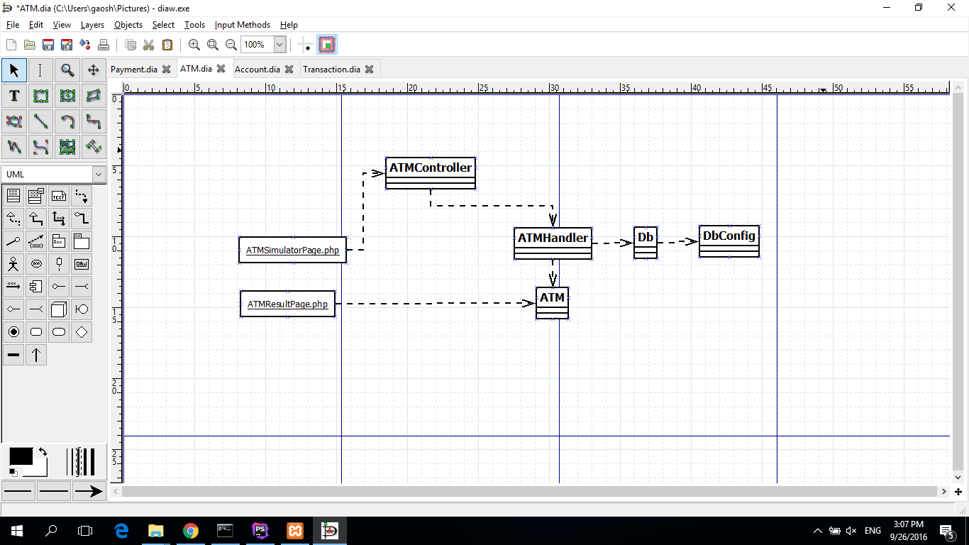

# 3. Database schema and relations

### Database Diagram

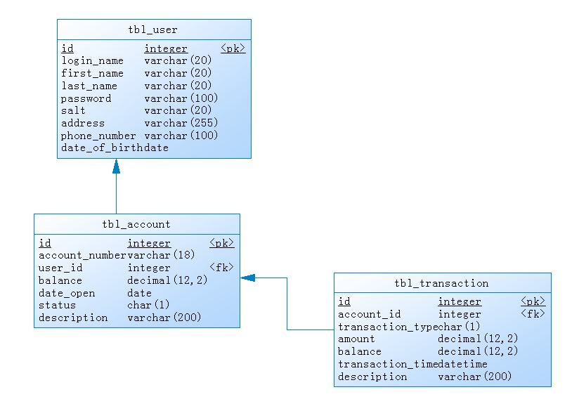

# 4. Installation instructions

## 4.1 Vagrant up and Vagrant SSH is done

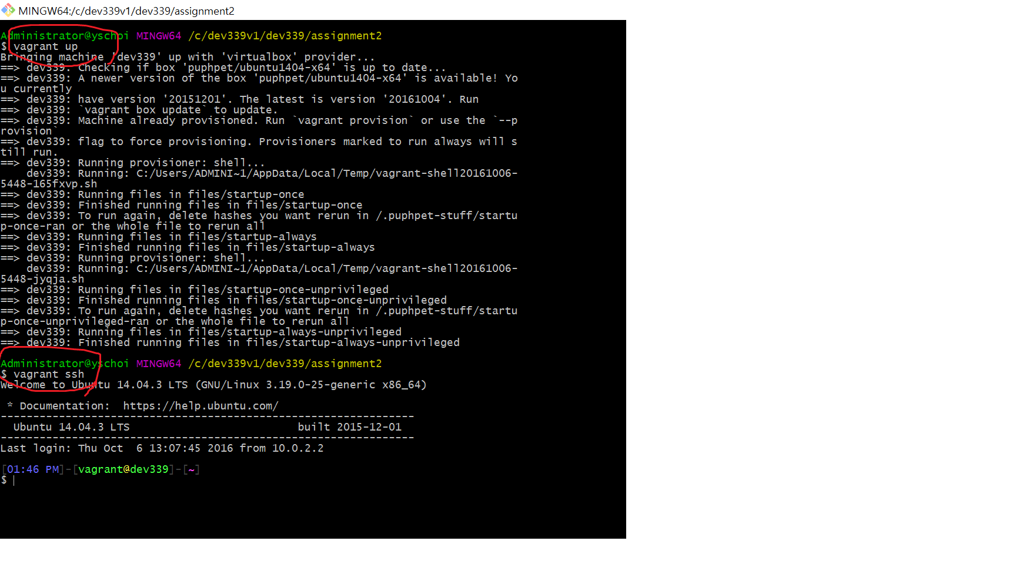

## 4.2 Type the directory where sqldump.sql (cd /vagrant/dev339/sql) and check files

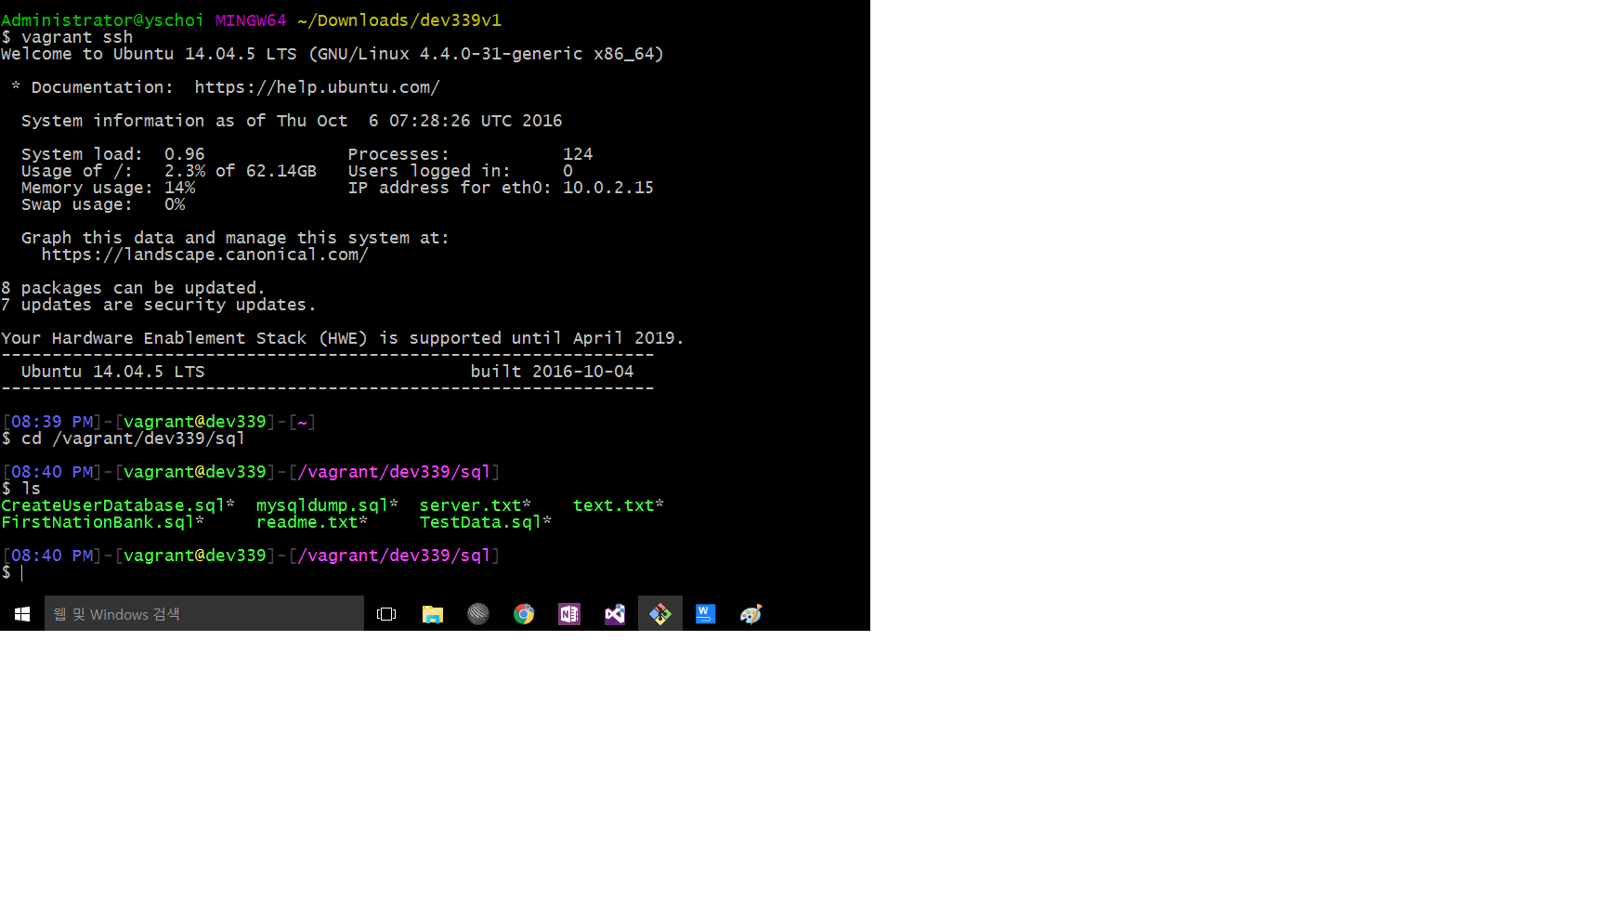

## 4.3 Type MySQL -uroot -p

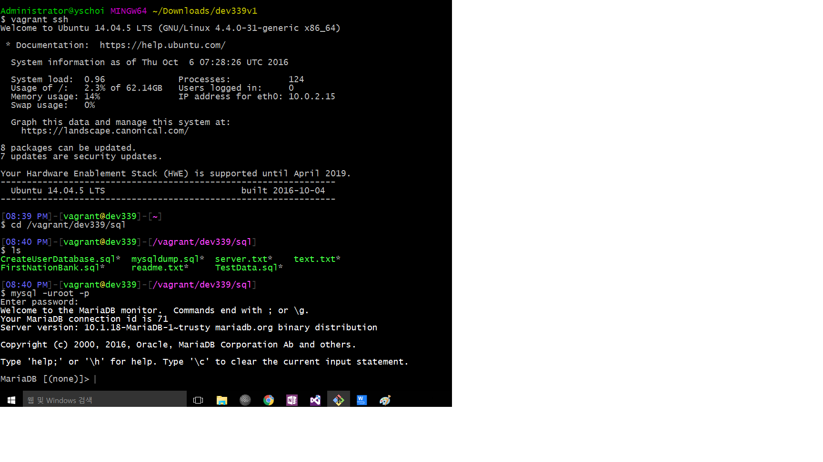

## 4.4 Type Source sqldump.sql

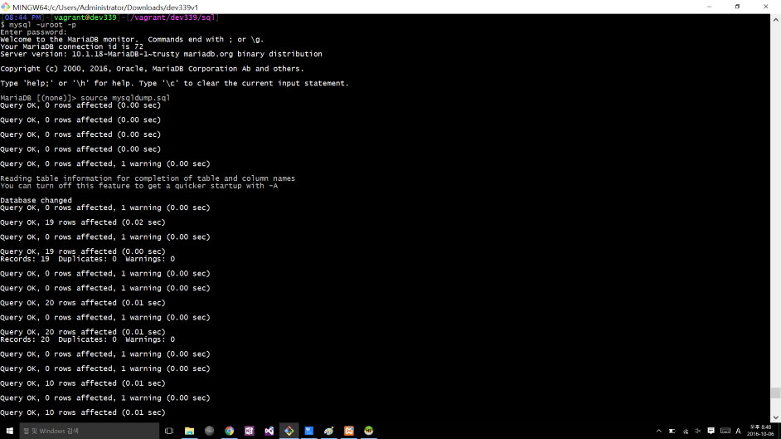

## 4.5 Type select* from table name for checking db is working

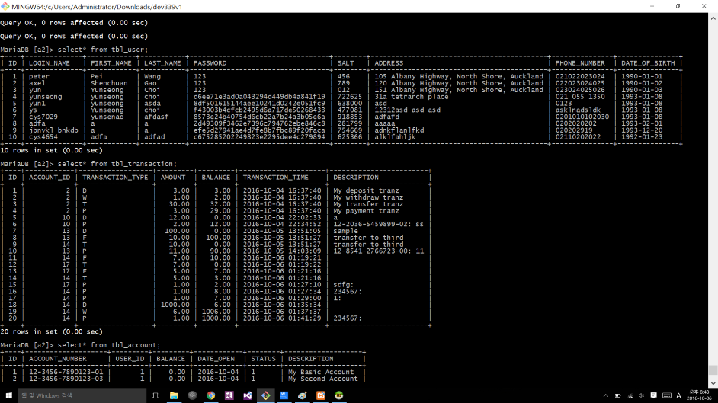

## 4.6 Check Working with dev339.local

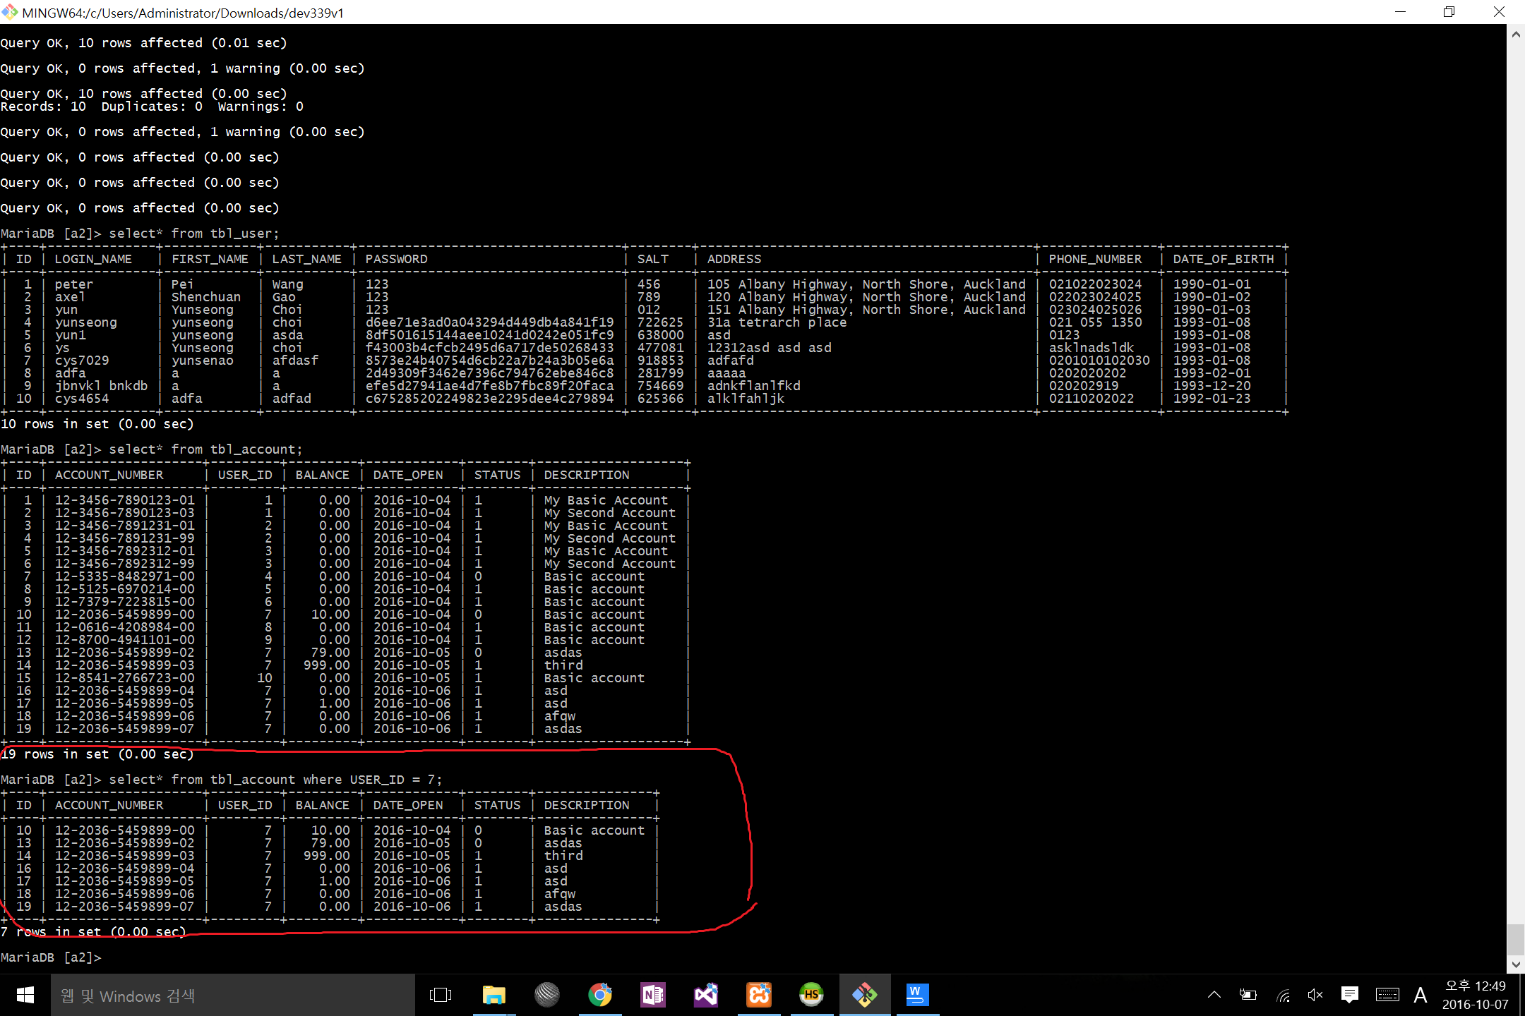

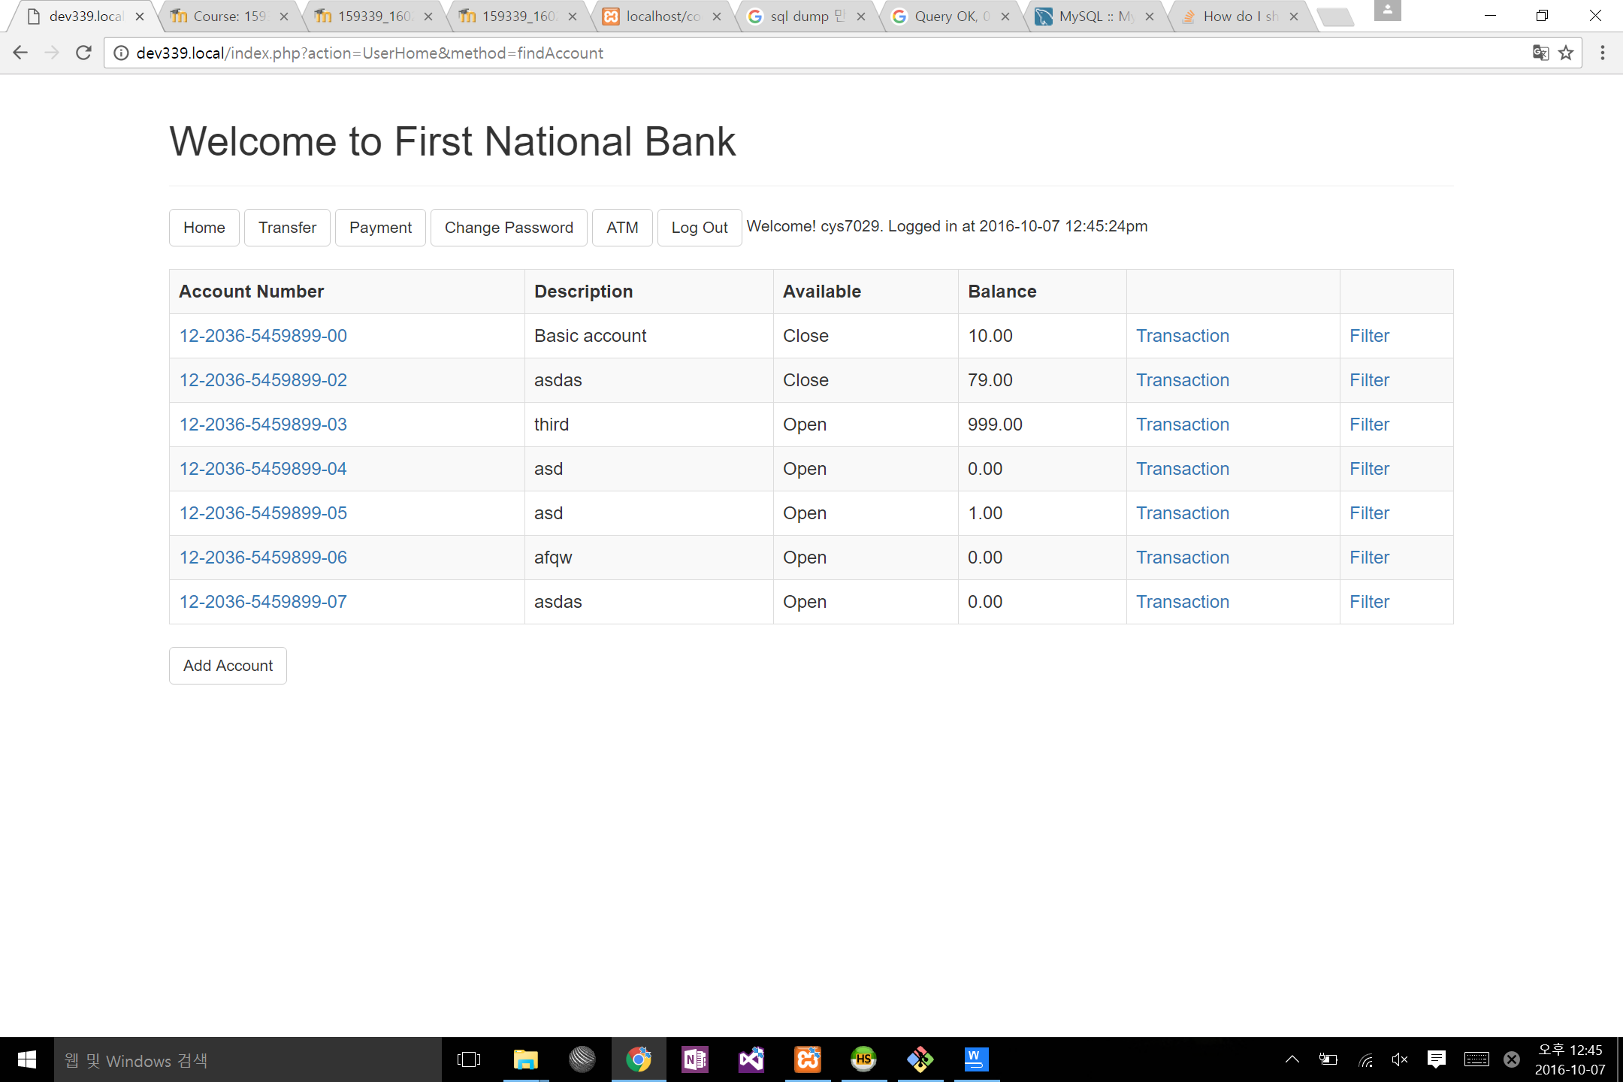

# 5. Instructions for end-user

## 5.1 Description of Running Environment

Because Apache, MySQL, MariaDB and PHP are not easy to handle, for the First Bank Project we strongly recommend the user to install XAMPP, which is the most popular PHP development environment:

### for Windows

Using the installer: The XAMPP control panel for start/stop Apache, MySQL, FileZilla & Mercury or install these server as services.

### for Linux

Choose your flavor for your linux OS, the 32-bit or 64-bit version.

Change the permissions to the installer. “chmod 755 xampp-linux-*-installer.run”

Run the installer. “sudo ./xampp-linux-*-installer.run”

### for Mac OS X

Open the DMG-Image. Double-click on the image to start the installation process.

## 5.2 How to Use Functions

### Join

Choose Join link:

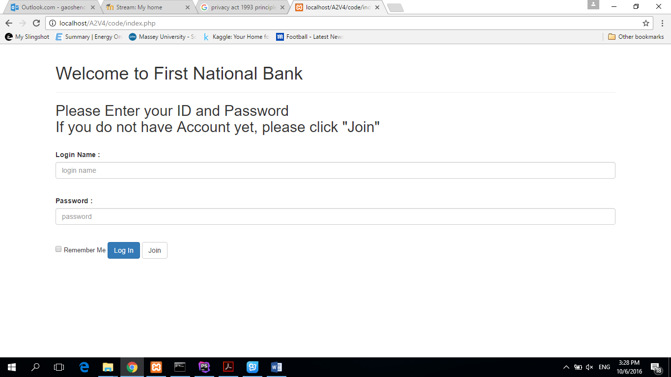

Fill the form, then click “submit” button:

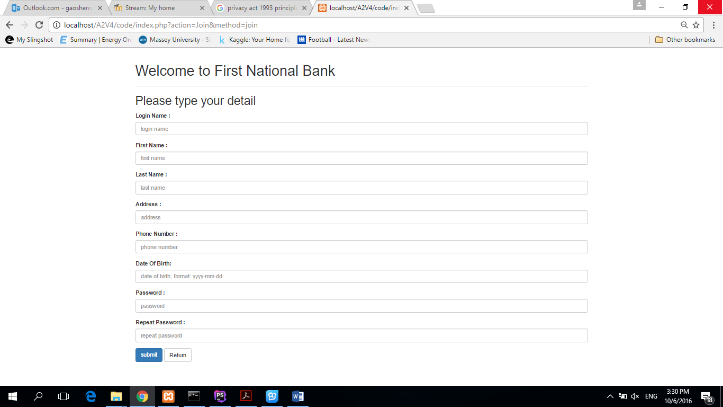

### Login

Log in with ID and Password. Can click “Remember Me”:

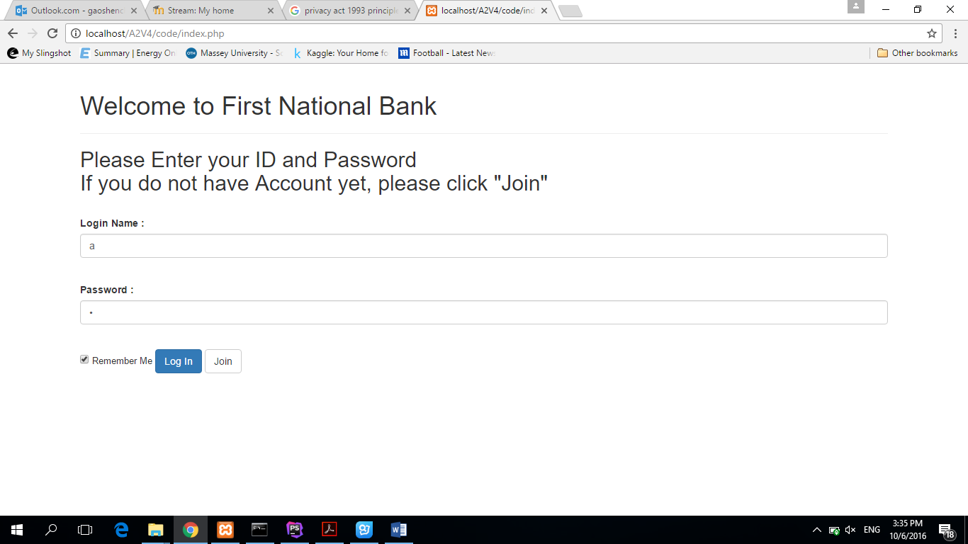

Then attend the user homepage:

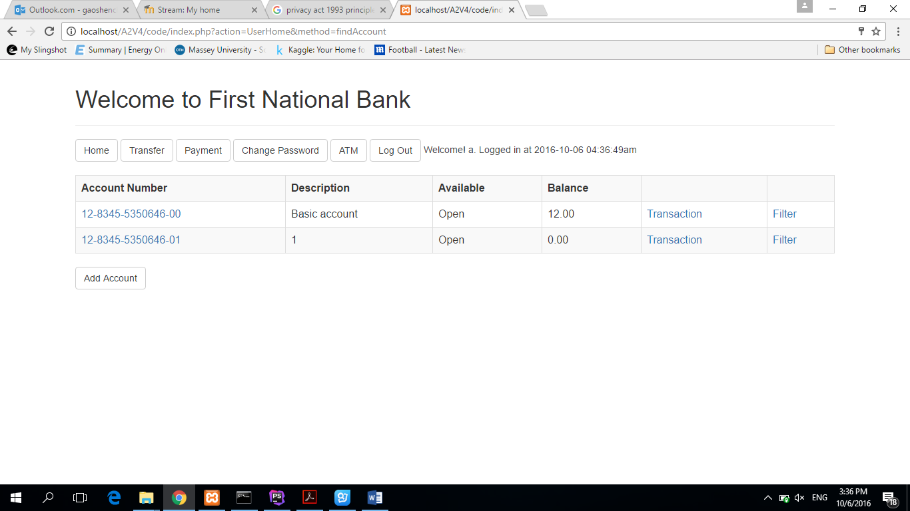

### Add Account

Click “Add Account” button to Add Account page, then fill the new account number and description:

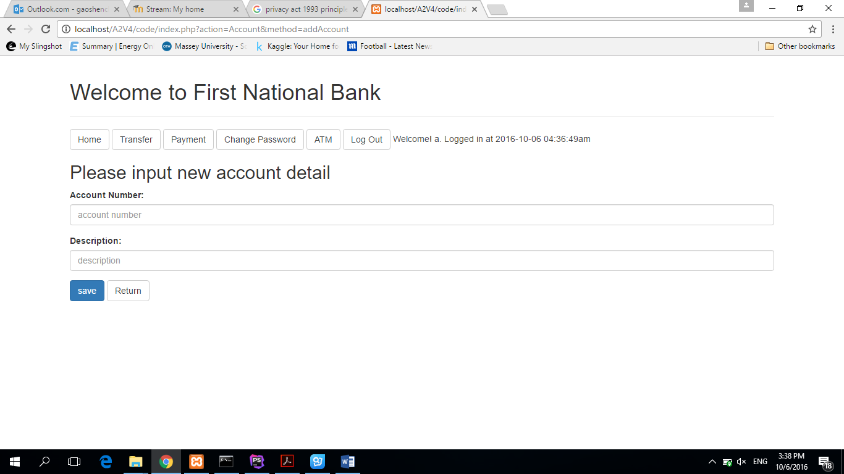

Then the user can read result page:

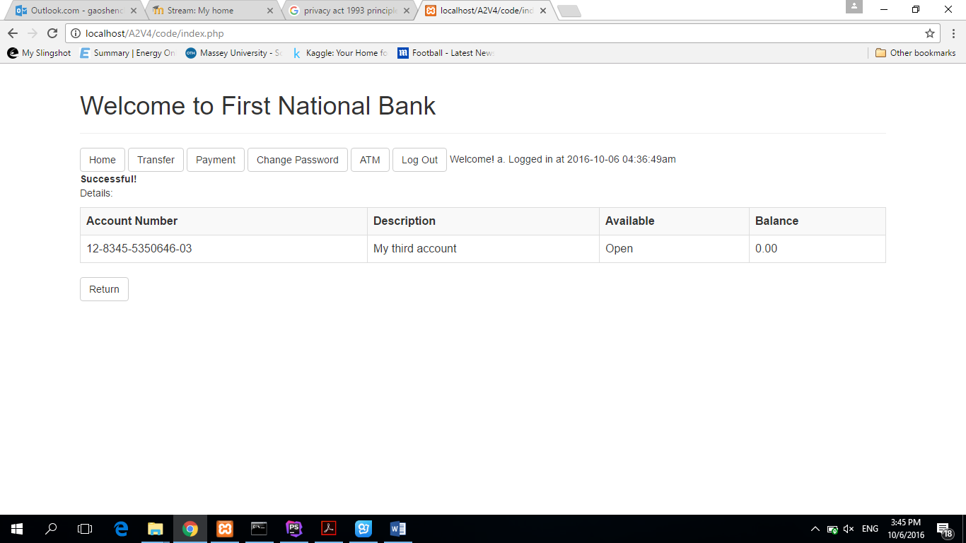

### Manage Account

On user homepage, clicking “Account Number” link can transfer to Account management page:

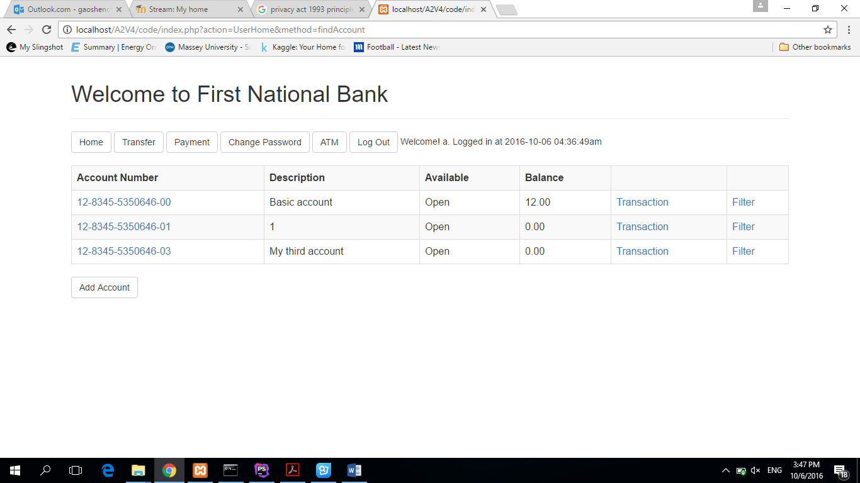

Then user can choose close the account:

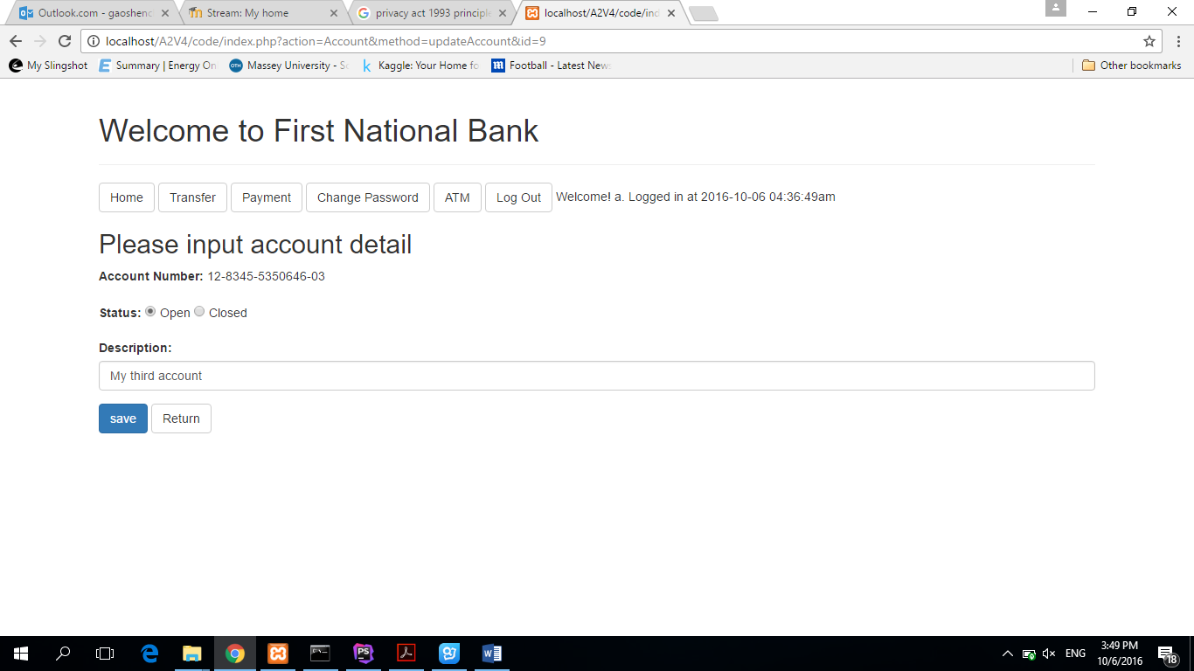

After click “save” button, user can read the information “Account number has closed.”:

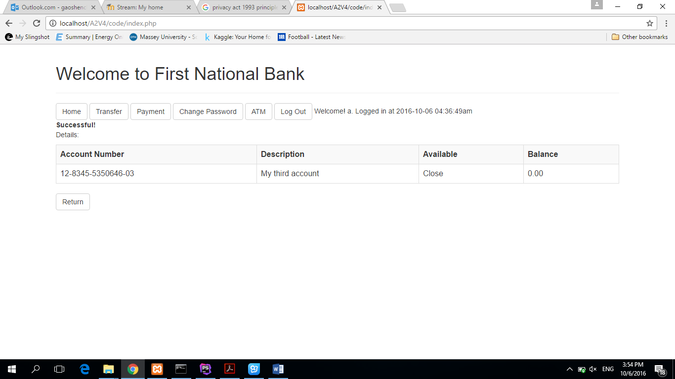

### Change Password

Click “Change Password” button to the new page:

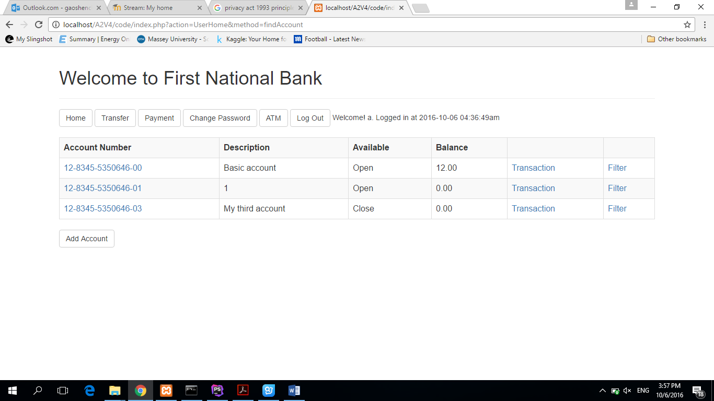

Input the old password and new password:

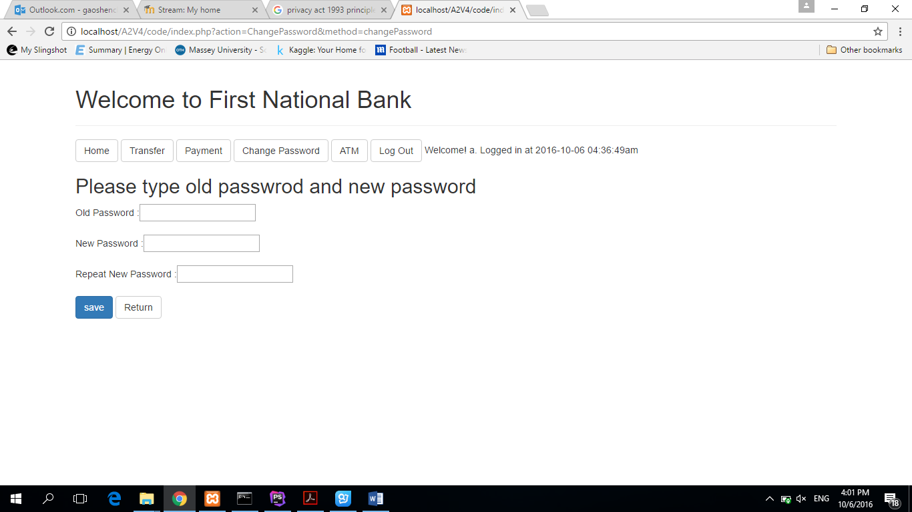

If the new and old password are the same, there will be an exception information:

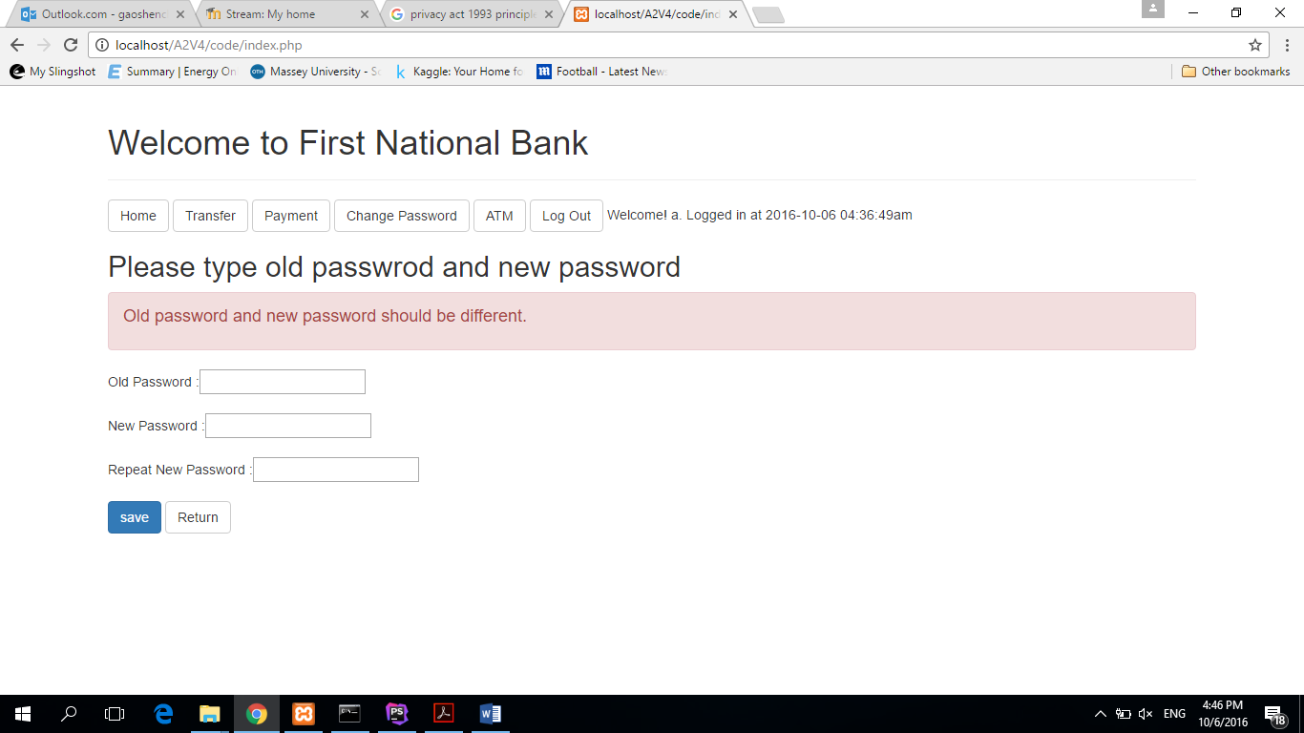

### Transfer

Click “Transfer” button to Transfer page:



Choose the source account and definition account, then input amount and description:

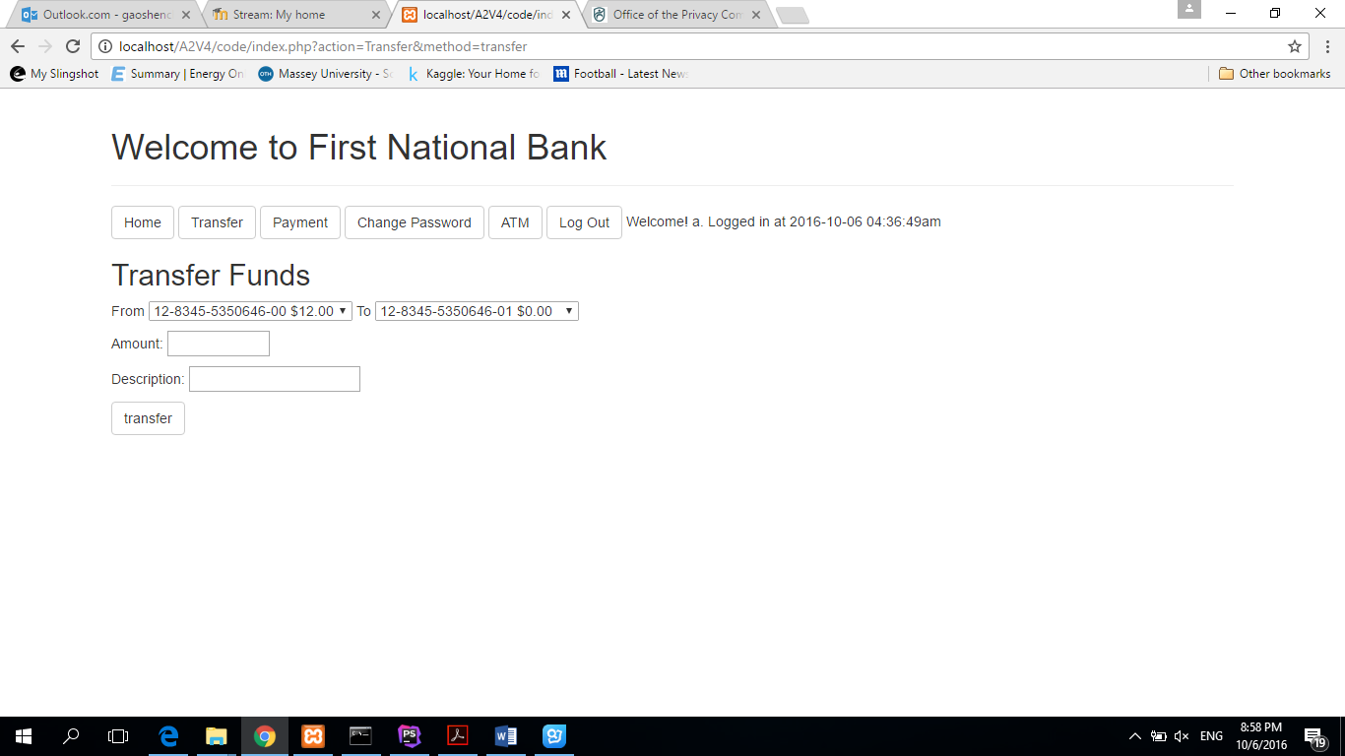

If transfer successful, there will be a successful result page shown:

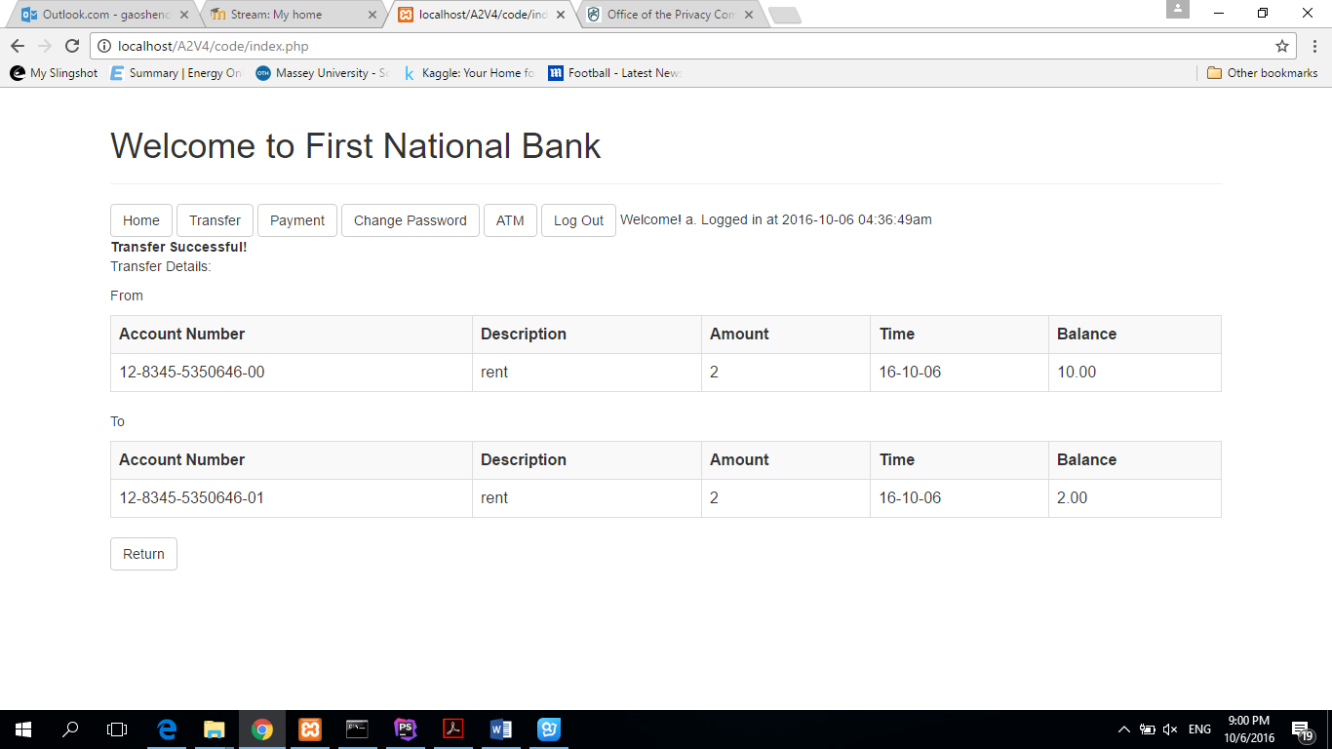

But if there is not enough balance in the source account, an exception information “balance not enough” will be showed:

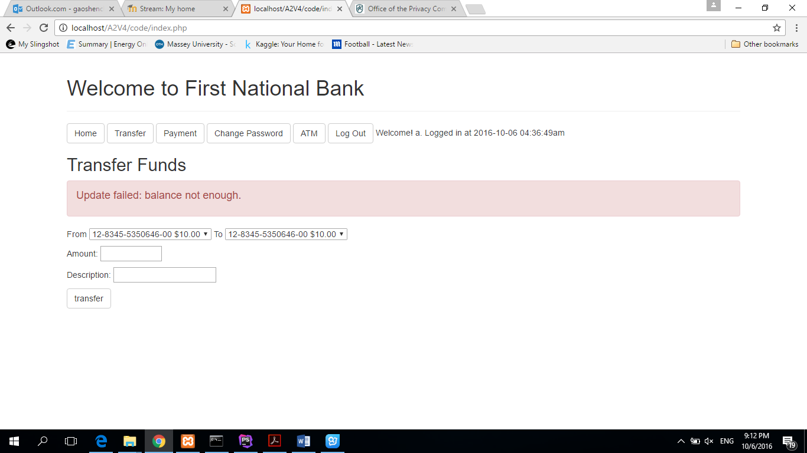

### Payment

Click “Payment” button to Payment page:



Choose the source account, then input definition account, amount and description:

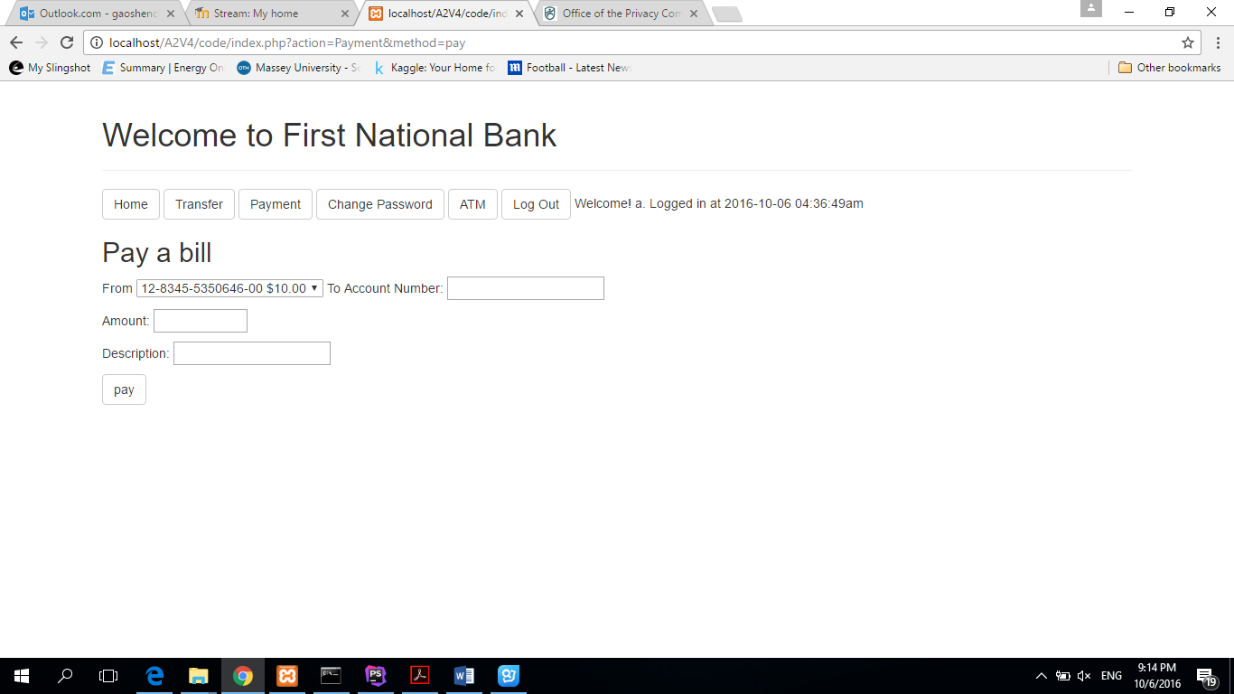

If payment successful, there will be a successful result page shown:

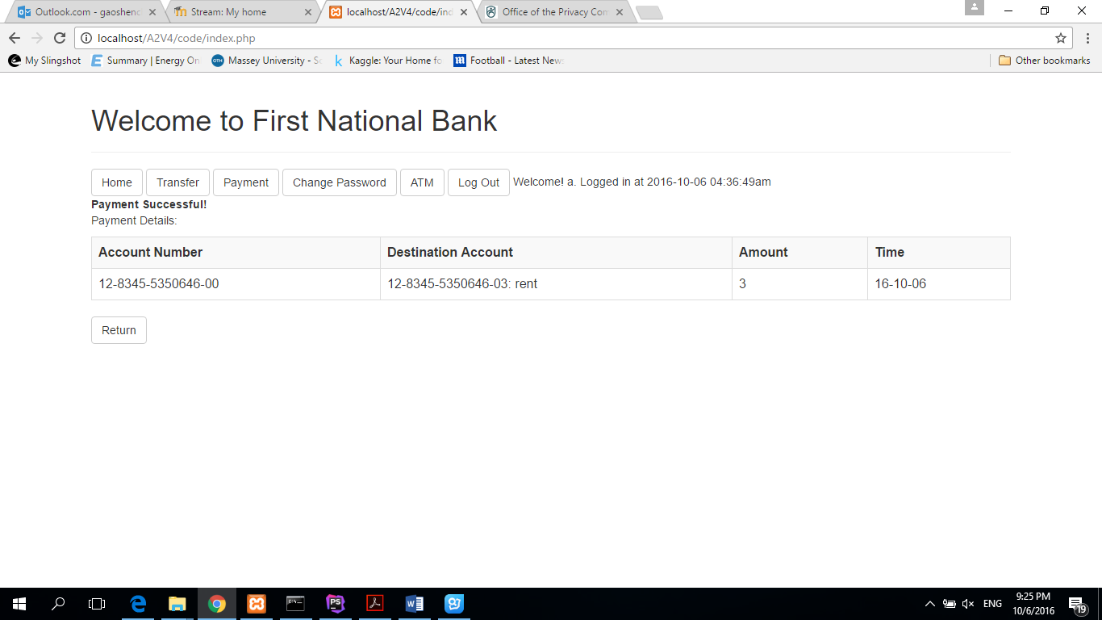

### ATM

Click “ATM” button to ATM page:



Choose the source account and function (withdraw or deposit), then input amount and description:

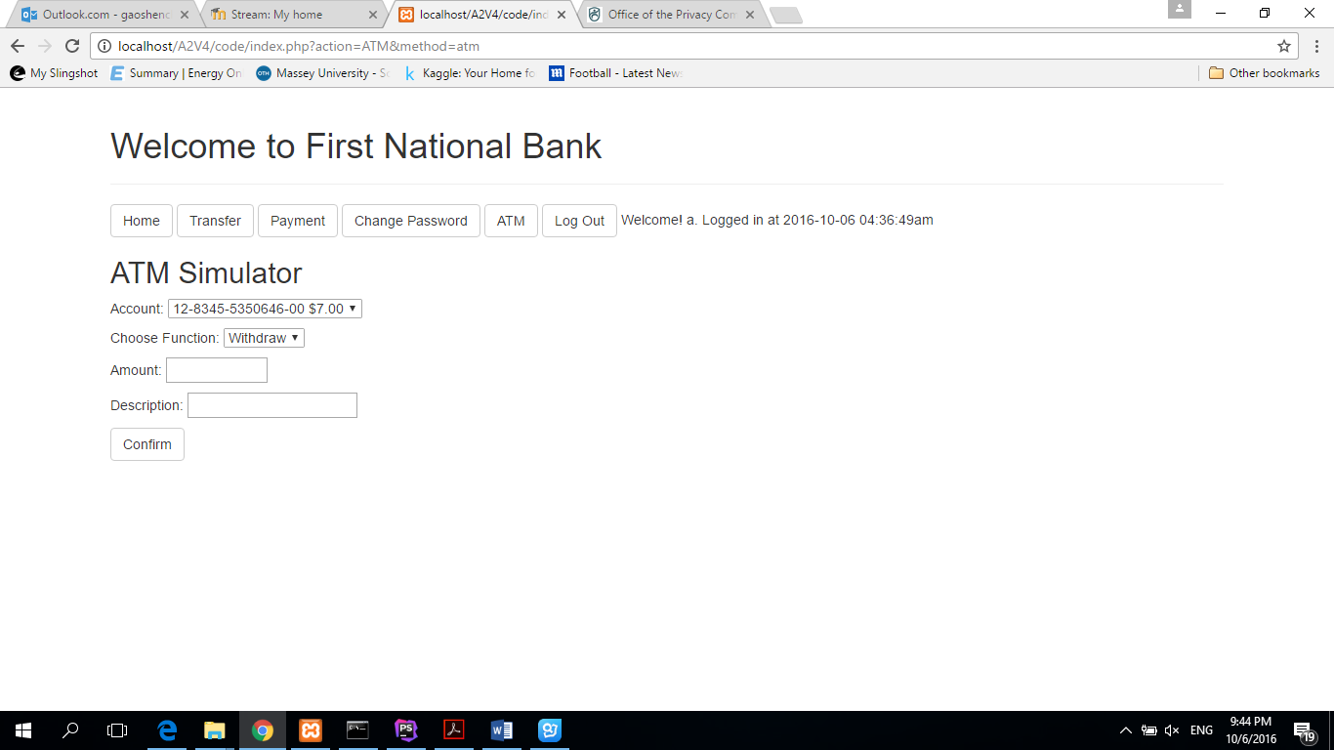

If function successful, there will be a successful result page shown:

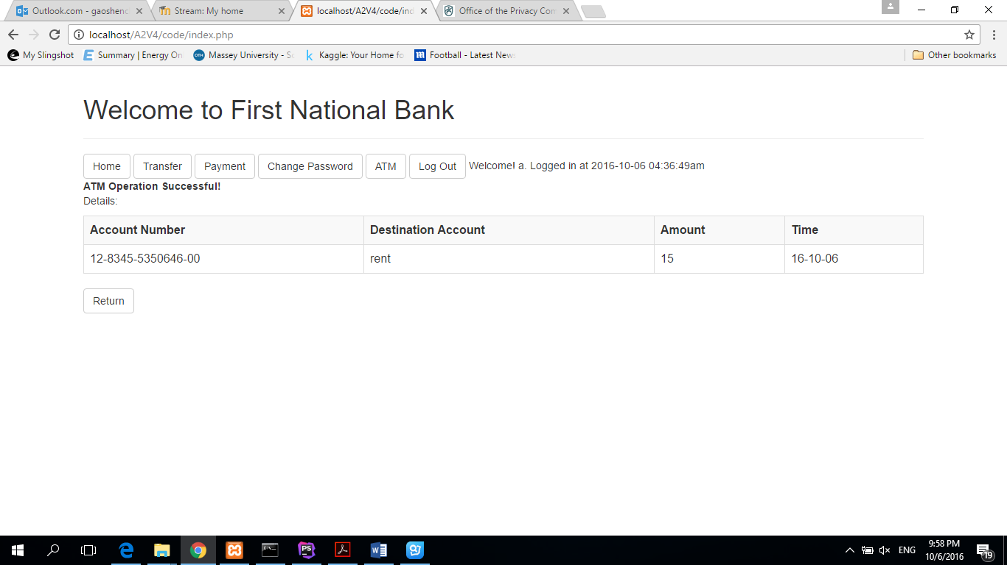

### Transaction List

Click “Transaction” link for the target account to Transaction List page:



Then input the custom date range on the transaction page:

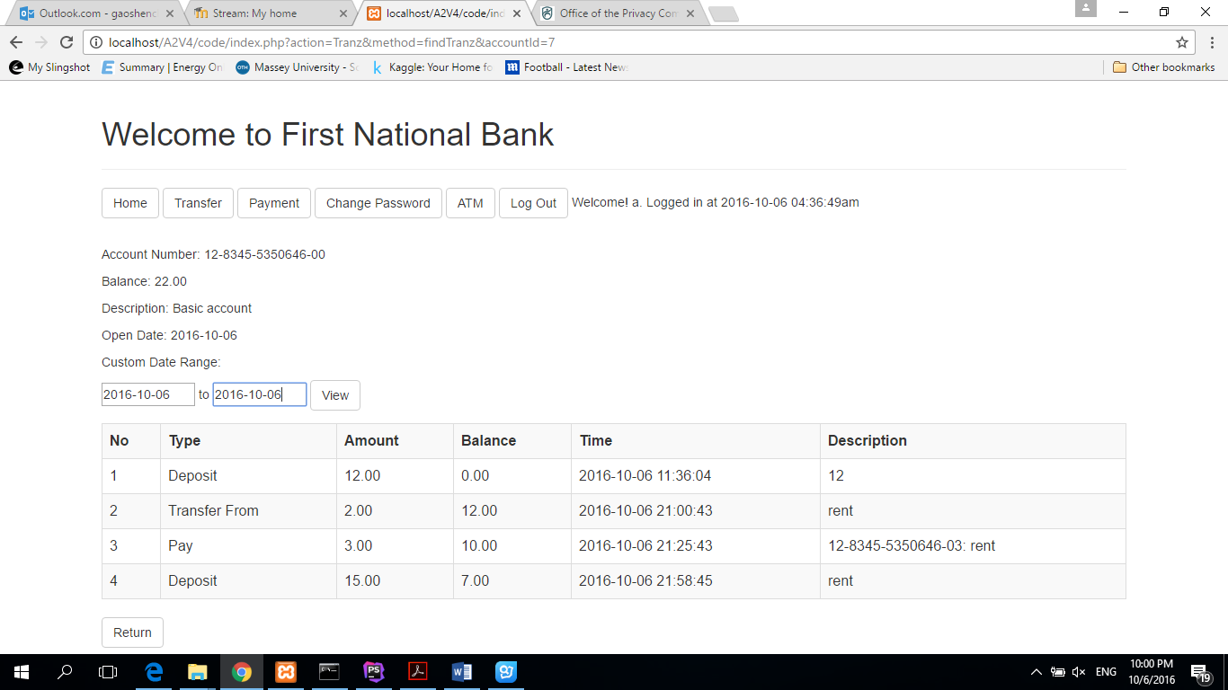

### Filter

Click “Filter” link for the target account to Filter page:



Then input the custom date range, function and order (ASC/DESC) on the transaction page:

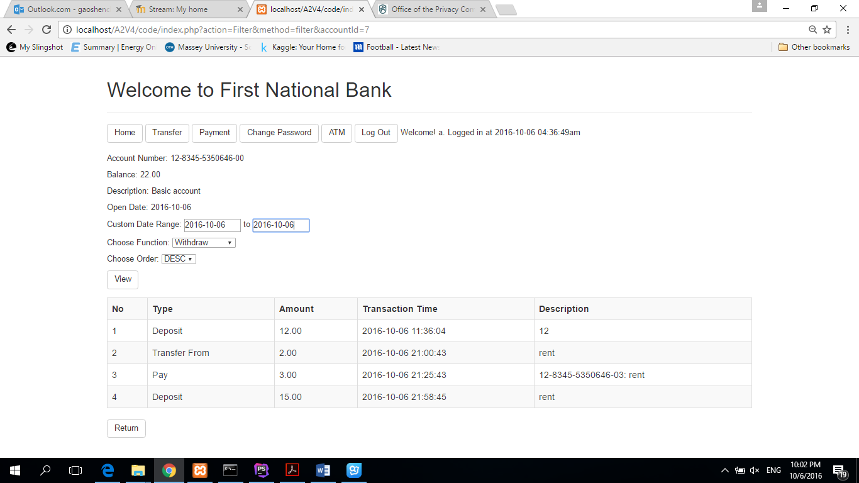

### Log out

Click “Log out” link for the target account to log out page:



**Thank you!**